A000-INDO-Sumba, Kodi Village-Figure-Ancestor-Female-Early 20th c

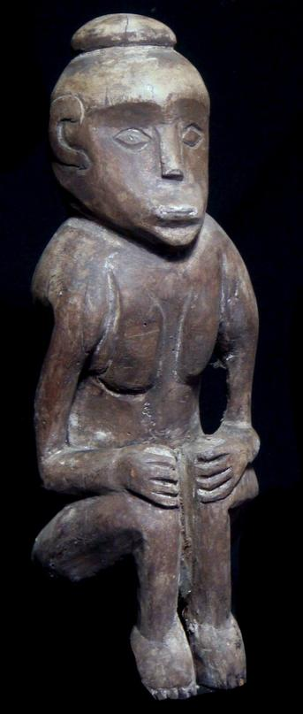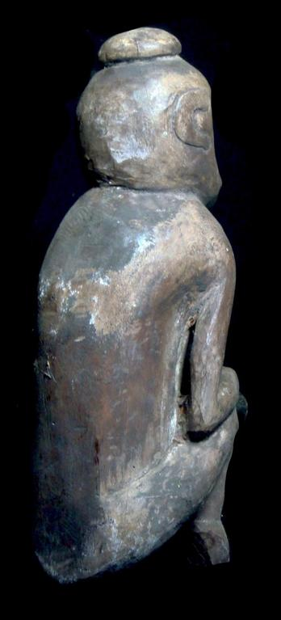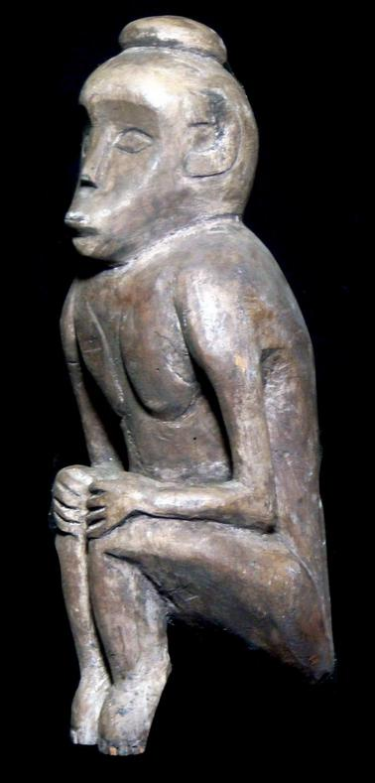

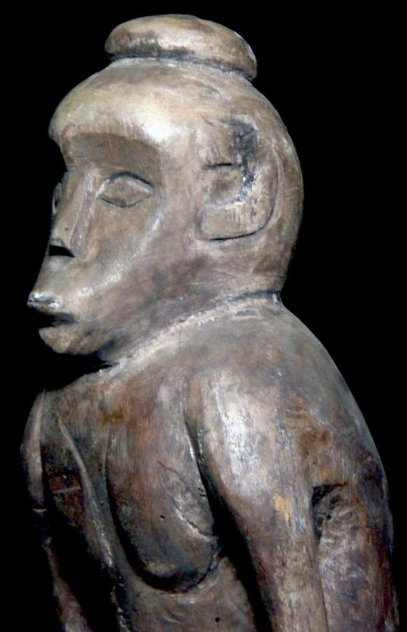

Figs. 1-4. INDO-Sumba, Kodi Village-Figure-Ancestor-Female-Early 20th c

Case No.: Oceania

**Accession No.**

**Formal Label:** INDO-Sumba, Kodi Village-Figure-Ancestor-Female-Early 20th c

**Display Description:**

Carved wooden ancestral figure from Kodi, the western most part of the island of Sumba. Sumba is one of the large islands in the Nusa Tenggara group of Indonesia. The religious specialist who carved this ancestress statue was intimately familiar with the deceased and the deceased’s family so that essential traits could be incorporated into the finished sculpture such as the hair bun, the hands on the knees, the curled toes as though in concentration and the expressive puckering of the mouth while listening to a request for advice.

Despite these individualized aspects of the sculpture, *Sumbawa* sculptural imagery was conventionalized, which depicted the ancestor in a seated or standing position with portrait details.

**LC Classification:**

**Date or Time Horizon:** Early 20th c

**Geographical Area: Kodi, Sumba**

**Map:**

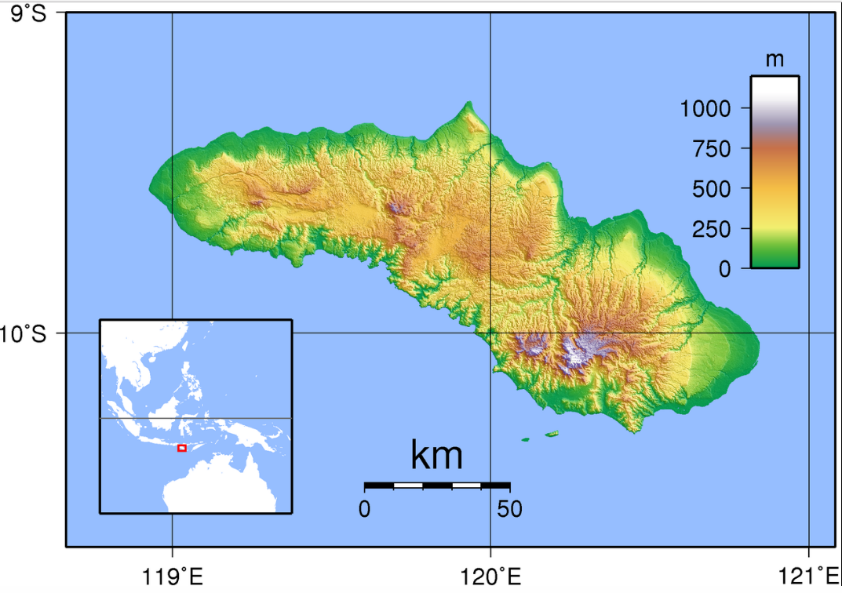

Topographic map of Sumba. Created with GMT from SRTM dat after [Sadalmelik](https://commons.wikimedia.org/wiki/User:Sadalmelik) own work 11 September 2007.

**GPS coordinates: 10o S, 19o  E**

**Cultural Affiliation:**

**Media:**

**Dimensions:**

**Weight:**

**Condition:**

**Provenance:**

**Discussion:**

**References:**

Adams, R.L. and King, S.M., While the study and interpretation of mortuary practices have long been important parts of archaeological analyses, rarely has residential burial–the practice of burying the deceased in and around houses–been a specific focus of investigation. Here, we examine some of the global contexts in which residential burial has occurred and discuss the different ways that archaeologists have interpreted... *Archeological Papers of the American Anthropological Association*, *20*(1), pp.121-135.

Barbier, J.P. and Newton, D. eds., 1988. *Islands and ancestors: indigenous styles of Southeast Asia*. Prestel Pub.

Universitas Gadjah Mada, 1953. *The revival of sculpture in Indonesia*. Universitas Gadjah Mada.